**Landlord Tenant Management System**

**By Purva Pathak**

**INDEX**

|  |  |  |
| --- | --- | --- |
| **Sr. No** | **Title** | **Page No.** |
| 1. | Problem Definition. | **5** |
| 2. | Existing System. | **6** |
| 3. | Proposed System. | **7** |
| 4. | Requirement Analysis | **8** |
| 5. | Scope of the system | **9** |
| 6. | Feasibility study | **10** |
| 7. | ERD. | **13** |
| 8. | UML Diagrams. | **14** |
| 9. | Data Dictionary | **21** |
| 10. | Sample I/O Screen | **25** |
| 11. | Conclusion | **29** |
| 12. | Future Enhancement | **30** |
| 13. | Bibliography | **31** |

# PROBLEM DEFINATION

* 1. There are lots of people who have lots of flats to give on rents and they have to maintained a big file for their tenant records or documents. Even they have to maintained their rents details using some notebooks or diaries.
  2. It has been difficult for landlord to maintain all these details of tenant and even to retrieve the details of tenants for any reasons, and also Landlord had to make a list of occupied flats and empty flats.
  3. The present project elucidates the following features.
  4. Registering the Tenants
  5. Modification of Tenants Information
  6. Searching a tenant.
  7. Monthly rents of tenants and billing of rents.

# EXISTING SYSTEM

* + There are lots of other systems present like Hotel management system, Hostel Management System but No one worked on Tenant Management System earlier according to my knowledge.

# PROPOSED SYSTEM

To reduce the work-load of Landlord, we proposed Landlord Management System, where landlord does not need to maintain big-big files and diaries for tenant’s records and rents instead of that Landlord can do all these things using our system.

## Advantages:

* + - Easy to Use.
    - Tenants Documents can be stored.
    - Rent detail can be stored easily.
    - Rent receipt in one click.
    - Landlord can know Occupied Flats in one click.
    - Landlord can fetch the details of tenant in one click.
    - Tenants details can be updated easily.
    - Landlord can deactivate the Tenants once he/she leaves the flat easily.

# REQUIREMENT ANALYSIS

**Software Environment:** Software Environment is a technical specification of requirement of software product. This specifies the environment for development, operation and maintenance of the product.

Technology used:

* JAVA

* POSTGRESQL

**Hardware Configuration:**

* + - Processor : Intel Core
    - RAM : 512 MB RAM
    - Hard Disk Drive : 40 GB HDD
    - Keyboard : 104 keys
    - Monitor : 15” digital color monitor

**Software Configuration:**

* + - Operating System : Windows xp,Vista,7 or any one
    - Frontend Language : JAVA [SWINGS, AWT, JDBC]
    - Backend Language : POSTGRESQL

# SCOPE OF THE SYSTEM

There are lots of people who have lots of flats to give on rents and they have to maintained a big file for their tenant records or documents. Even they have to maintained their rents details using some notebooks or diaries. It has been difficult for landlord to maintain all these details of tenant and even to retrieve the details of tenants for any reasons, and also Landlord had to make a list of occupied flats and empty flats.

To reduce the work-load of Landlord, we proposed Landlord Management System, where landlord does not need to maintain big-big files and diaries for tenant’s records and rents instead of that Landlord can do all these things using our system.

The present project elucidates the following features.

* + - * Registering the Tenants.
      * Modification of Tenants Information.
      * Searching details of tenants.
      * Searching of empty flat.
      * Monthly rents of tenants and billing of rents.
      * Deactivate the Tenants.

# FEASIBILITY STUDY

Preliminary investigation examines project feasibility, the likelihood the system will be useful to the organization. The main objective of the feasibility study is to test the Technical, Operational and Economical feasibility for adding new modules and debugging old running system. All system is feasible if they are unlimited resources and infinite time. There are aspects in the feasibility study portion of the preliminary investigation:

* + Technical Feasibility
  + Operation Feasibility
  + Economical Feasibility

## 1.Technical Feasibility:

The technical issue usually raised during the feasibility stage of the investigation includes the following:

* + Does the necessary technology exist to do what is suggested?
  + Do the proposed equipment’s have the technical capacity to hold the data required to use the new system?
  + Will the proposed system provide adequate response to inquiries, regardless of the number or location of users?
  + Can the system be upgraded if developed?
  + Are there technical guarantees of accuracy, reliability, ease of access and data security?

Earlier no system existed to cater to the needs of ‘Landlord Tenants management system’. The current system developed is technically feasible. It is a application based user interface. Thus it provides an easy access to the users.

The database’s purpose is to create, establish and maintain a workflow among various entities in order to facilitate all concerned users in their various capacities or roles. Permission to the users would be granted based on the roles specified. Therefore, it provides the technical guarantee of accuracy, reliability and security.

The software and hardware requirements for the development of this project are not many and are already available or are available as free as open source. The work for the project is done with the current equipment and existing software technology.

## 3. Operational Feasibility:

Proposed projects are beneficial only if they can be turned out into information system. That will meet the organization’s operating requirements. Operational feasibility aspects of the project are to be taken as an important part of the project implementation. Some of the important issues raised are to test the operational feasibility of a project includes the following: -

* + Is there sufficient support for the management from the users?
  + Will the system be used and work properly if it is being developed and implemented?
  + Will there be any resistance from the user that will undermine the possible application benefits?

This system is targeted to be in accordance with the above- mentioned issues. Beforehand, the management issues and user requirements have been taken into consideration. So there is no question of resistance from the users that can undermine the possible application benefits.

The well-planned design would ensure the optimal utilization of the computer resources and would help in the improvement of performance status.

## 3. Economic Feasibility:

A system can be developed technically and that will be used if installed must still be a good investment for the organization. In the economical feasibility, the development cost in creating the system is evaluated against the ultimate benefit derived from the new systems. Financial benefits must equal or exceed the costs.

The system is economically feasible. It does not require any addition hardware or software. Since the interface for this system is developed using the existing resources and technologies, there is nominal expenditure and economical feasibility for certain.

# ER DIAGRAM

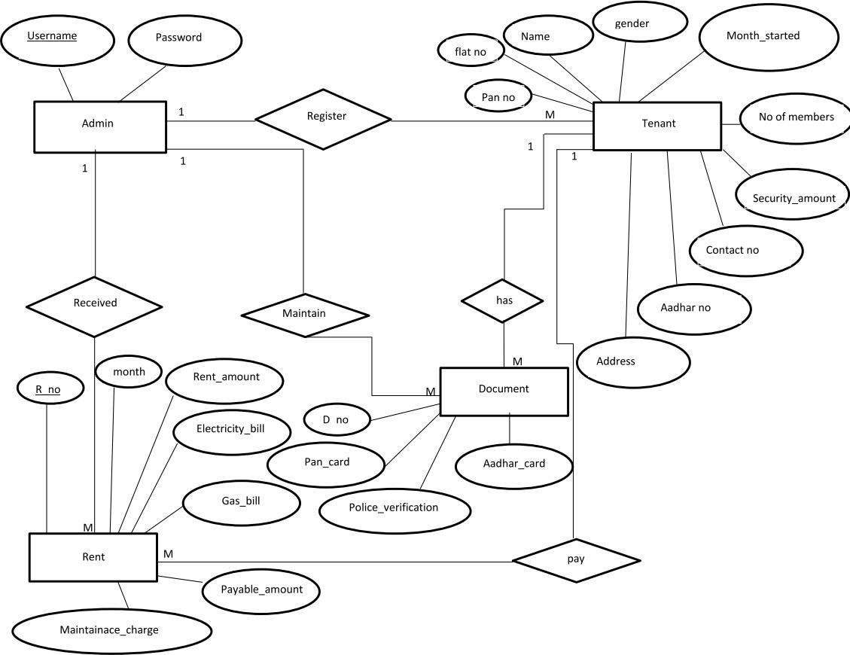

ER Diagram for Landlord Rent Management System

1. **Class Diagram:**

# UML DIAGRAMS

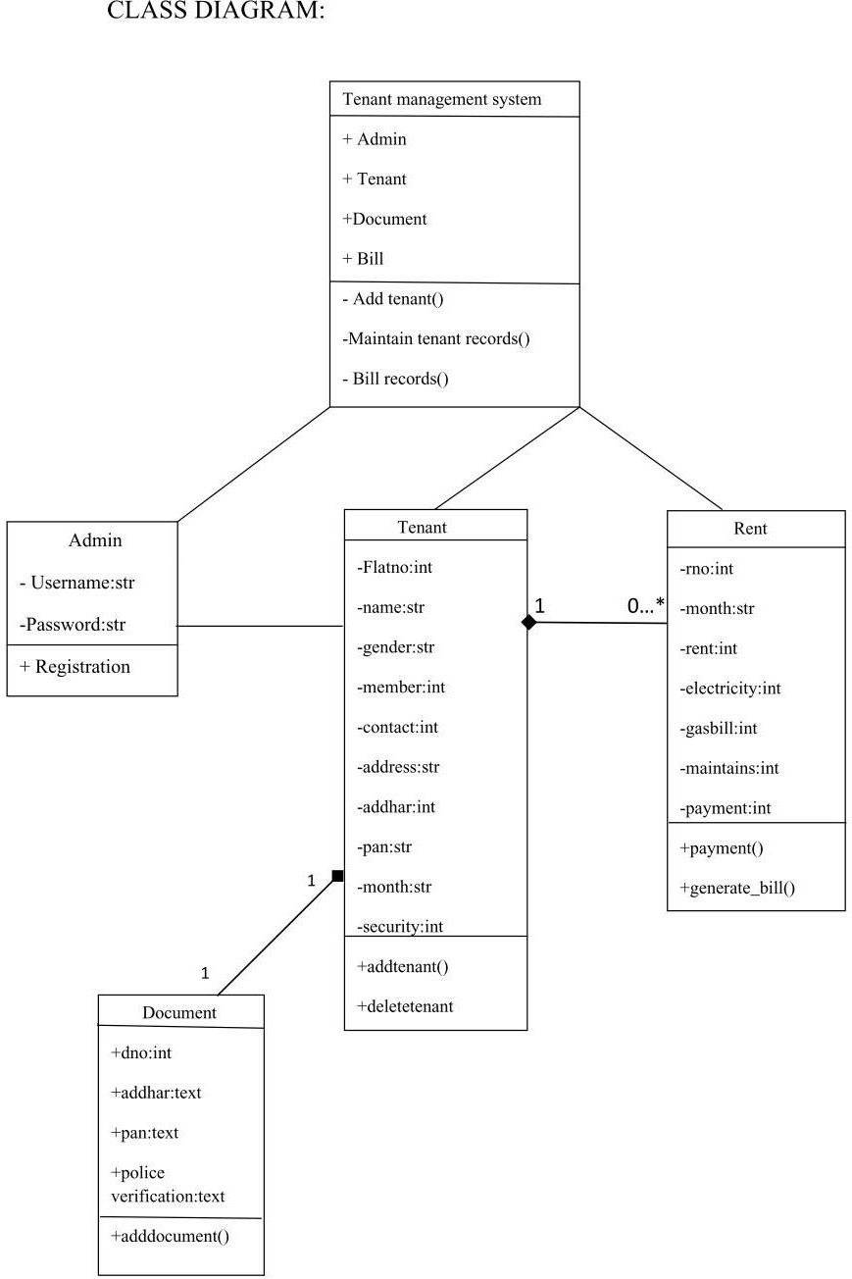

## Use Case Diagram:

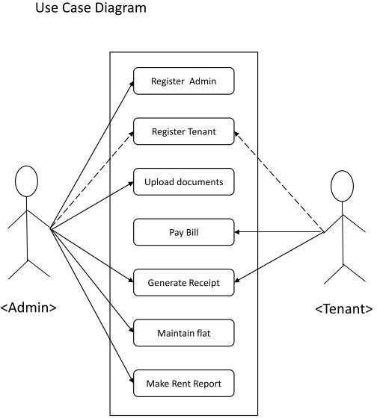

Use Case diagram for Landlord Tenant management system

## Sequence Diagram:

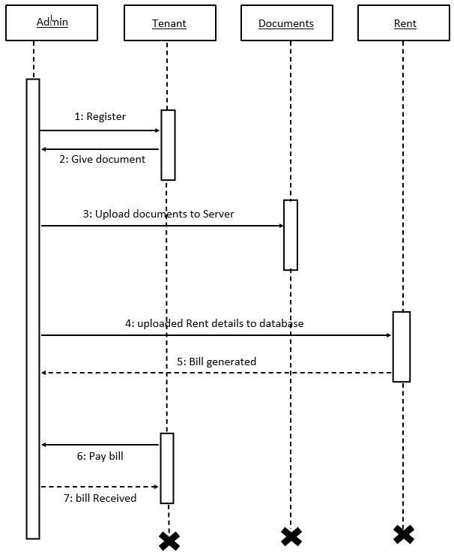

Sequence diagram for Landlord Tenant management system

## Activity Diagram: Admin

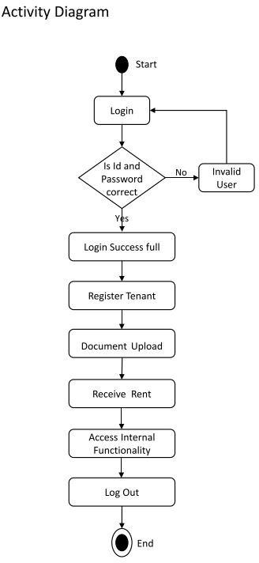

Activity diagram of admin for Landlord Tenant management system

## Collaboration Diagram:

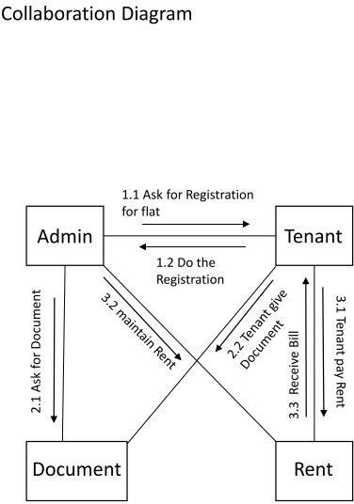

Collaboration diagram for Landlord Tenant management system

## State Diagram:

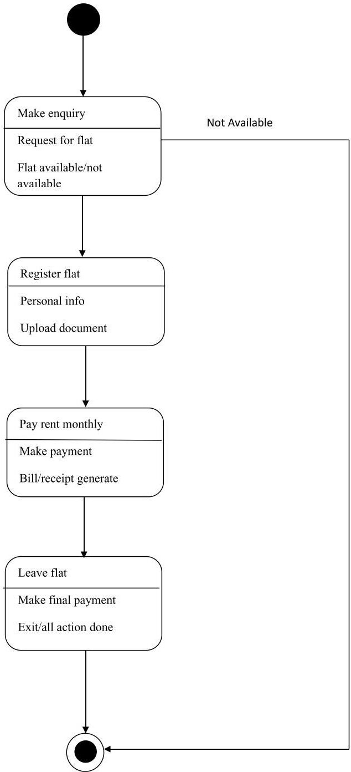

State-chart diagram for Landlord Tenant management system

## Deployment Diagram:

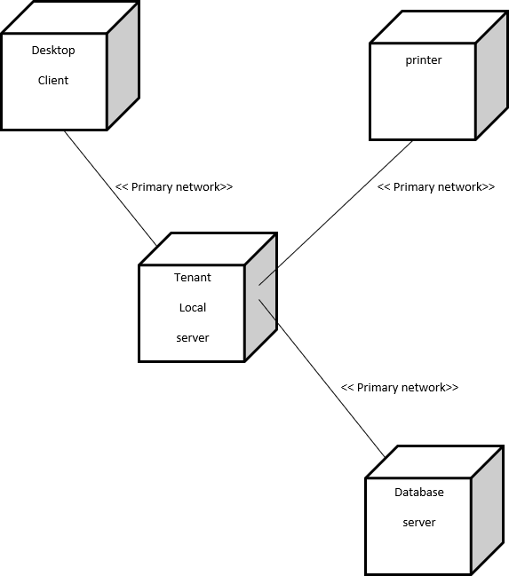

Deployment diagram for Landlord Tenant management system

# DATA DICTIONARY

The efficiency of an application developed using RDBMS mainly depend upon the database tables, the fields in each table and the way the tables are opened using the contents in them to retrieve the necessary information. Hence a careful selection of tables and their fields are imperative.

The database tables used in this system are created keeping the above points in mind. The tables used are given below.

## POSTGRESQL Table Structure

**Table Name: register**

**Description:** - This Table is store info about admin login details

Column |

Type

|Constraints |

username | character varying(20) | not null

|

password | character varying(20) | not null

|

Indexes:

"register_pkey" PRIMARY KEY, btree (username)

## Table Name: tenant

**Description:** - This Table stores tenant information

Column

|

Type

| Constraints |

+ + +

flatno

| integer

| not null

|

name

| character varying(20) | not null

|

gender

| character varying(10)| not null

|

no_of_members | integer

| not null |

contact_no

| numeric(10,0)

| not null |

address

| character varying(100)| not null |

aadhar_no

| numeric(12,0)

| not null |

pan_no

| character varying(10) | not null |

months_started | character varying(12) | not null |

security_amount | integer

| not null |

Indexes:

"tenent_pkey" PRIMARY KEY, btree (flatno)

## Table Name: document

**Description:** - This Table is store documents of tenant.

Column

| Type | Constraints |

+ -+ +

flatno

| integer |

|

|  |  |  |  |
| --- | --- | --- | --- |
| dno | | integer | | not null | | |
| aadhar | | text | | | | |
| pan_card | | text | | | | |
| police_verification | | text | | | | |

Indexes:

"document_pkey" PRIMARY KEY, btree (dno)

## Table Name: rent

**Description: -** This Table is store rents information

Column

|

Type

| Constraints |

+ + + +

rno

| integer

| not null

|

month

| character varying (12) | not null |

|  |  |  |  |
| --- | --- | --- | --- |
| rent_amount | | integer | | not null | | |
| electricity_bill | | integer | | not null | | |
| gas_bill | | integer | | not null | | |
| maintanance_charge | integer | not null | | | | |
| payable_amount | | integer | | not null | | |
| flatno | | integer | | | | |
| date | | date | | | | |
| Indexes: |  |  |  |

"rent_pkey" PRIMARY KEY, btree (rno)

# SAMPLE I/O SCREEN

## Login Page:

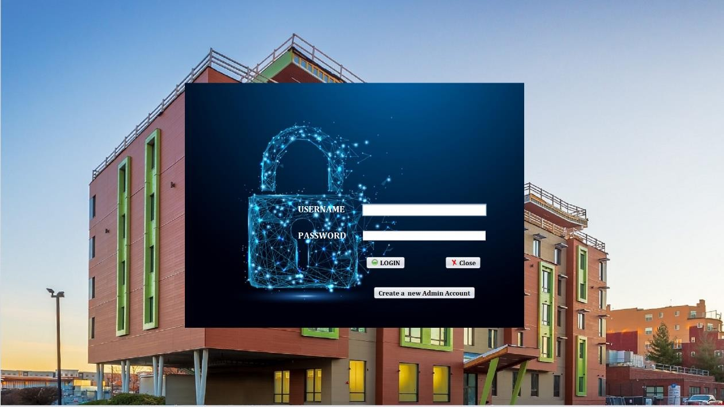

**Home Page:**

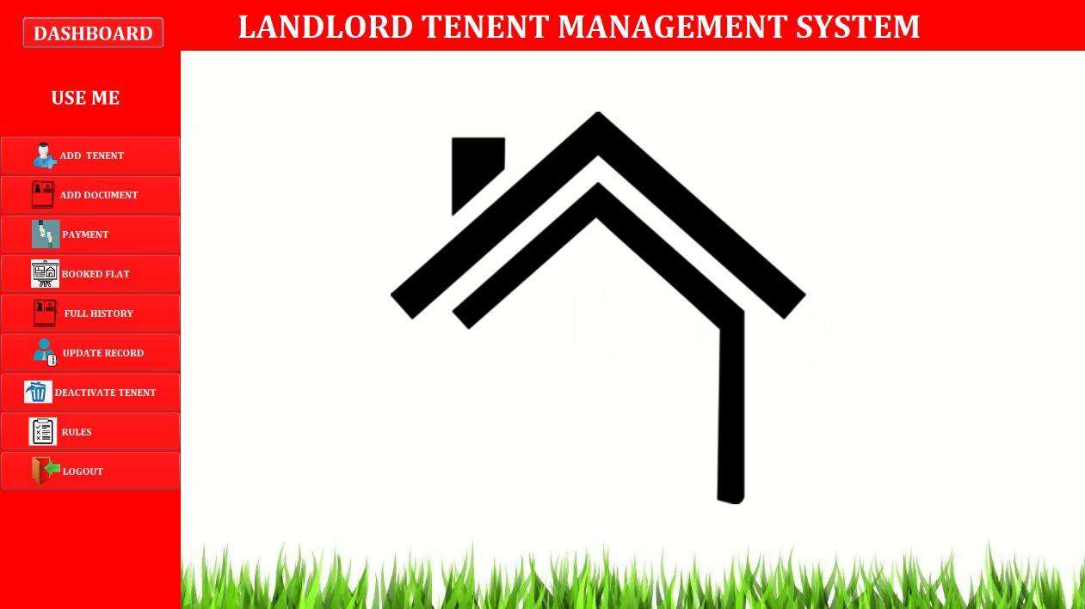

## Add Tenant page:

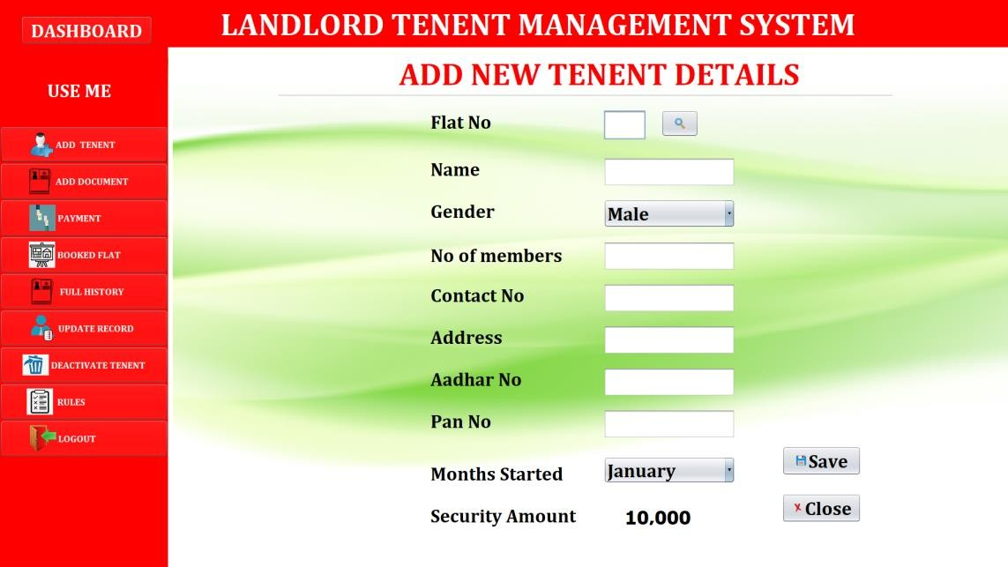

**Rent page:**

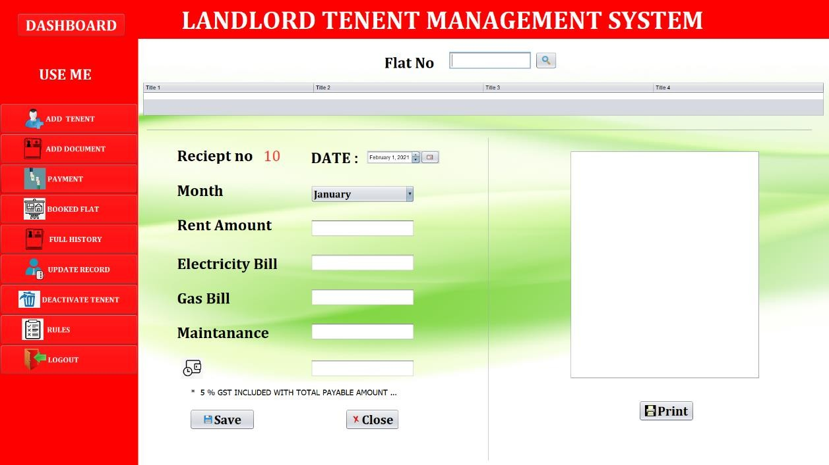

## Flats Detail page:

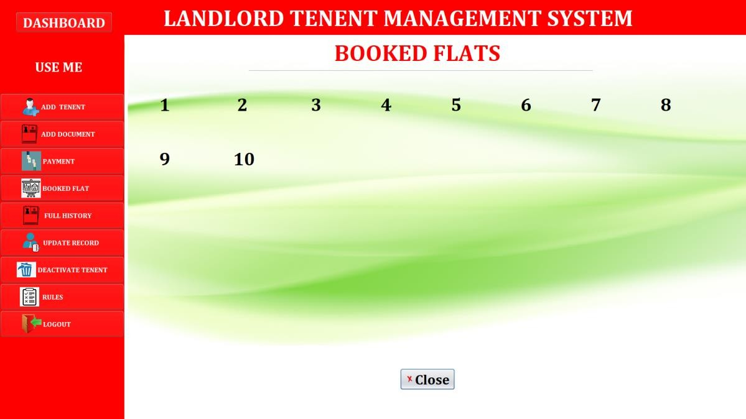

**Full History Page**:

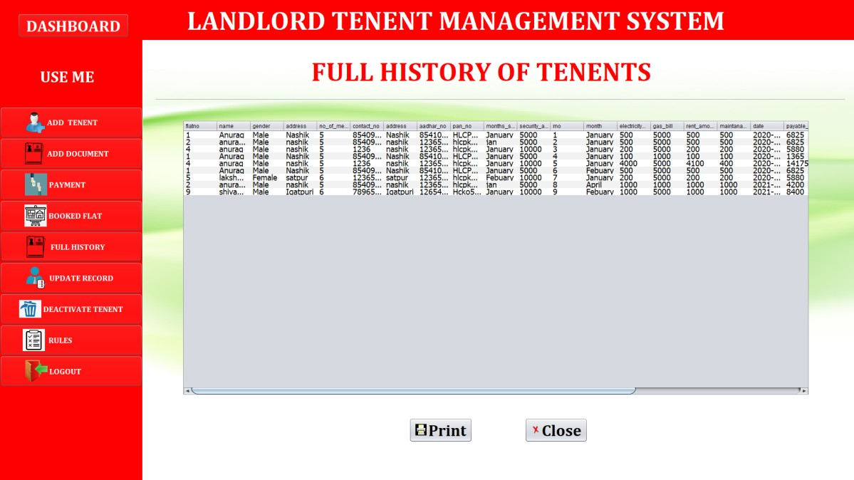

**Rules page:**

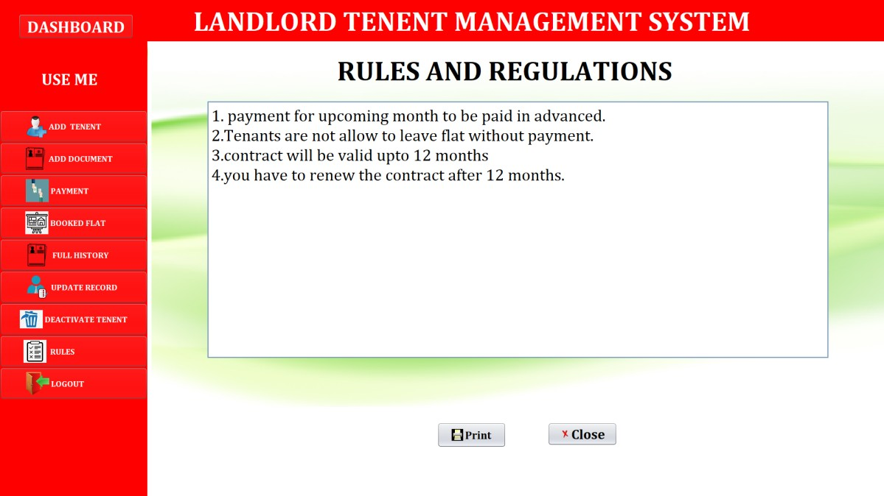

# CONCLUSION

This project has given me an ample opportunity to design, code, test and implements an application. This has helped in putting into practice of various Software Engineering principles and Database Management concepts like maintaining integrity and consistency of data. Further, this has helped me to learn more about POSTGRESQL, JAVA, Adobe Photoshop 7.0.

I thank my guide for his invaluable contribution in guiding me throughout the project. I also thank my parents and friends who have supported and motivated me to complete this project successfully.

# FUTURE ENHANCEMENT

In Future, we are planning to make Android Application for managing the rents as well as tenants’ records for both of them (Landlord and Tenants), where landlords can send notification about pending rents to Tenants as well as Tenants can pay the rent amount online using UPI or debit cards and all the information will be stored on server.

Auto notification will be sent to the both landlord and tenants about monthly rents every month, and Automatic rent bill be sent to tenants’ email.

Page **32** of **32**